CAJUN RED BEANS AND RICE

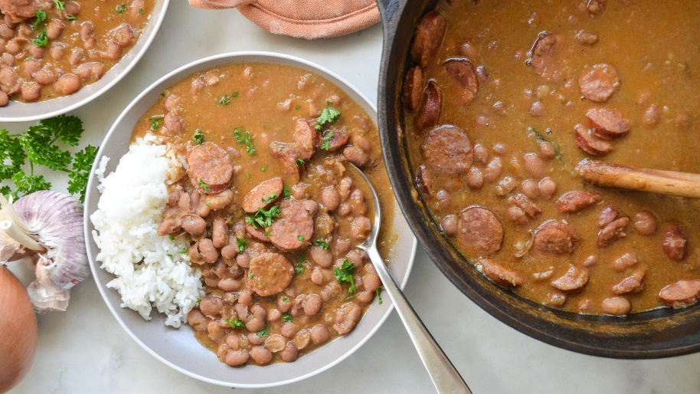

According to lore, people traditionally made this classic New Orleans dish on Mondays to coincide with laundry day. True or not, it’s definitely a bowl of steamy comfort worth waiting at least the length of one spin cycle. Creamy, smoky and slightly spicy, it will fill your home with mouth-watering anticipation while it bubbles on the stove.

Traditionally this recipe calls for red kidney beans, although it adapts well to many different types of bean. I used the Rancho Gordo [Lila Bean](https://www.ranchogordo.com/products/lila-beans-1?_pos=5&_sid=39ea4bce1&_ss=r&variant=2570820995), a pretty pink-purple variety.

Our [Hot Cajun Blackening Spice](https://oaktownspiceshop.com/collections/blends/products/hot-cajun-blackening-seasoning) adds notes of oregano and thyme along with a medium level of heat from cayenne. The resulting stew is mildly spicy; add more cayenne to produce a spicier version. Serve over steamed long-grain rice.

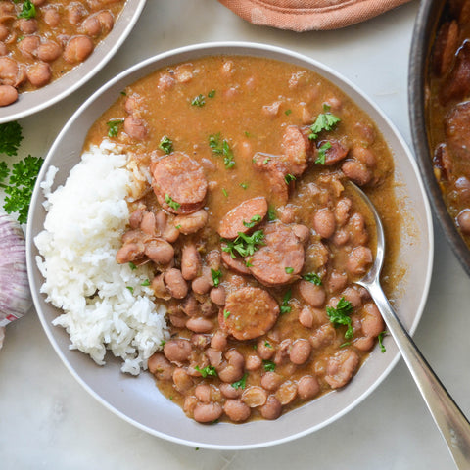

**Cajun Red Beans and Rice**

Serves 6

Ingredients:

1 pound dry red beans  
2 tablespoons vegetable oil   
1 pound Andouille sausage (fully cooked), sliced into rounds  
1 yellow or white onion, diced  
1 green bell pepper, diced  
3 celery stalks, diced  
4 cloves garlic, minced  
2 teaspoons [Spanish Smoked Paprika](https://oaktownspiceshop.com/collections/chiles/products/paprika-spanish-smoked)  
1 tablespoon [Hot Cajun Blackening Spice](https://oaktownspiceshop.com/collections/blends/products/hot-cajun-blackening-seasoning)  
6 cups water  
Flake salt, to taste  
2 tablespoons apple cider vinegar  
4 cups cooked long-grain rice   
Parsley, minced, for garnish

Directions:

Place the beans in a large bowl and cover with water. Soak for four hours or overnight. Drain and rinse.

Heat the oil over medium heat in a large Dutch oven or heavy-bottomed pot. When the oil is hot, add the sausage and cook until browned, about 8 minutes. Remove the sausage from the pot using a slotted spoon and set aside.

In the same pot, add the diced onion, bell pepper, celery and garlic. Sauté until softened, about 5 minutes. Add the smoked paprika and the Cajun seasoning and cook until aromatic, about another minute.

Add the drained beans and the 6 cups of water to the pot. Bring to a boil. Once boiling, turn the heat down to low and simmer, covered, until the beans are tender -- an hour or more, depending on soaking time and bean freshness.

Once the beans are tender, remove the lid and add the sausage to the pot. Add salt to taste. Continue to simmer on medium-low until the liquid becomes thicker and creamier, about 30 to 40 minutes.

Once the red beans have thickened, add more salt to taste if needed. Stir in the apple cider vinegar. Serve over steamed white rice and garnish with parsley if desired.

https://oaktownspiceshop.com/blogs/recipes/cajun-red-beans-and-rice?_pos=2&_sid=4ecbdd41f&_ss=r&mc_cid=f835bb8478&mc_eid=f211a2955b